**Fraud Transactions Analysis Pipeline**

**Pipeline Architecture:**

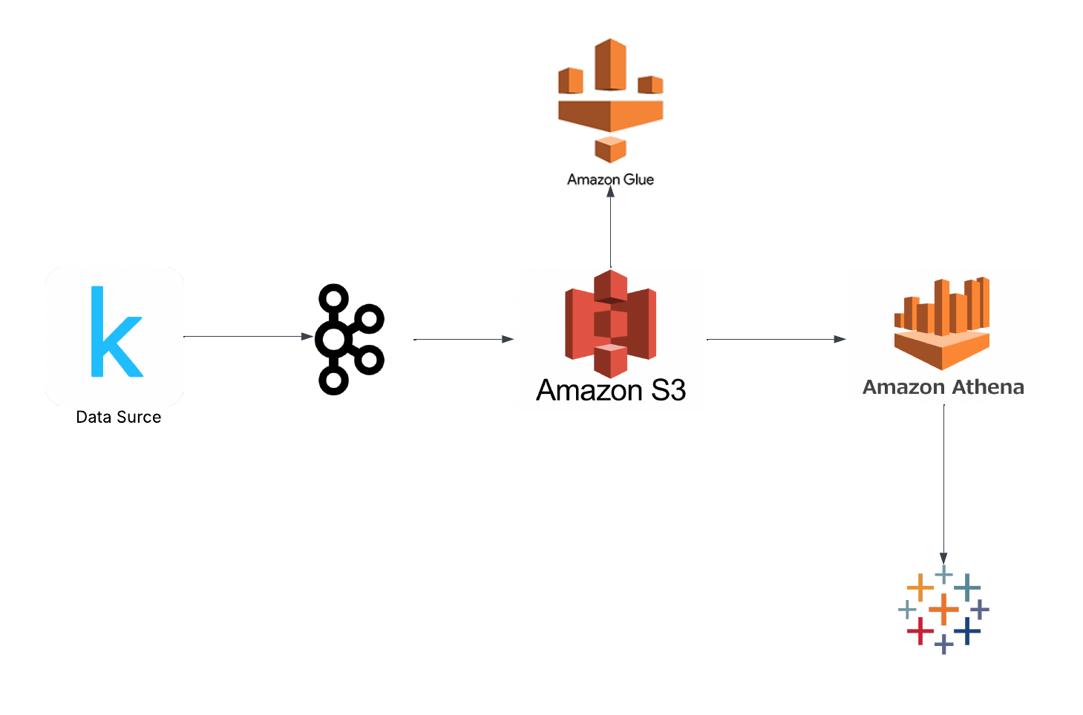

**Step 1:**

**Starting zookeeper**

./bin/zookeeper-server-start.sh config/zookeeper.properties

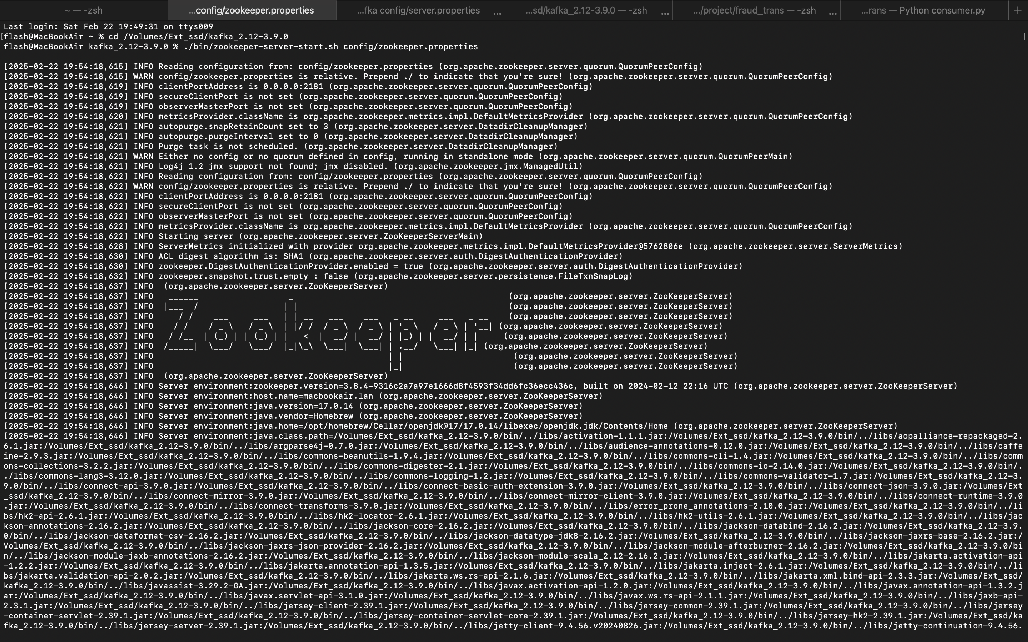

**Step 2:**

Starting Kafka server

./bin/kafka-server-start.sh config/server.properties

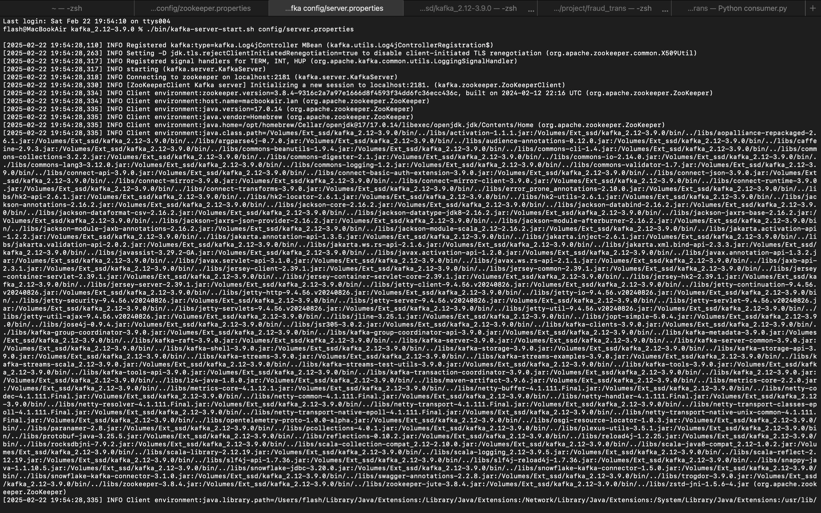

**Step 3:**

Creating topic – transactions

./bin/kafka-topics.sh --bootstrap-server localhost:9092 --create --topic transactions --partitions 1 --replication-factor 1



**Step 4:**

Producer.py

Code:

from kafka import KafkaProducer

import csv

import json

import time

producer = KafkaProducer(

bootstrap_servers='localhost:9092',

value_serializer=lambda v: json.dumps(v).encode('utf-8')

)

csv_file = "/Volumes/Ext_ssd/project/fraud_trans/creditcard.csv"

with open(csv_file, 'r') as file:

reader = csv.DictReader(file)

for row in reader:

producer.send('transactions', value=row)

print(f"Sent message: {row}")

time.sleep(0.01)

print("Data streaming to Kafka topic 'transactions' started.")

producer.flush()

producer.close()

Python3 producer.py

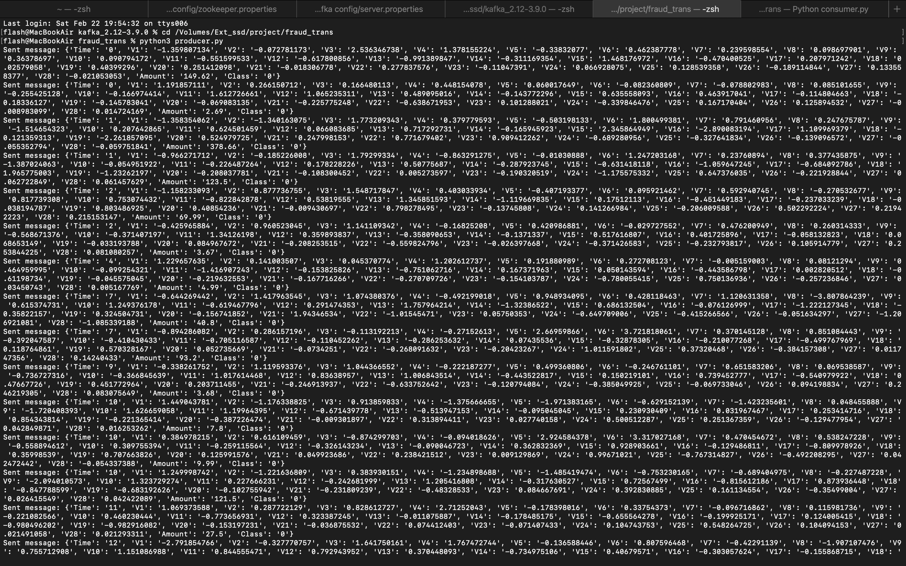

We can see the data stream from the data source sending to the topic.

**Step 5:**

Consumer.py:

Code:

from kafka import KafkaConsumer

import json

import boto3

import os

import csv

AWS_ACCESS_KEY = '’

AWS_SECRET_KEY = ‘'

S3_BUCKET_NAME = ‘’

session = boto3.Session(

aws_access_key_id=AWS_ACCESS_KEY,

aws_secret_access_key=AWS_SECRET_KEY,

)

s3 = session.client('s3')

consumer = KafkaConsumer(

'transactions',

bootstrap_servers='localhost:9092',

value_deserializer=lambda x: json.loads(x.decode('utf-8')),

auto_offset_reset='earliest',

enable_auto_commit=True,

group_id='fraud-trans-group'

)

print("Consuming messages from topic 'transactions'...")

batch_size = 1000

batch = []

counter = 1

expected_fields = ["Time"] + [f"V{i}" for i in range(1, 29)] + ["Amount", "Class"]

for message in consumer:

try:

data = message.value

cleaned_data = {

"Time": float(data.get("Time", 0.0)),

**{f"V{i}": float(data.get(f"V{i}", 0.0)) for i in range(1, 29)},

"Amount": float(data.get("Amount", 0.0)),

"Class": int(data.get("Class", 0))

}

batch.append(cleaned_data)

if len(batch) >= batch_size:

filename = f"fraud_transaction_batch_{counter}.csv"

filepath = os.path.join("/tmp", filename)

with open(filepath, 'w', newline='') as f:

writer = csv.DictWriter(f, fieldnames=expected_fields)

writer.writeheader()

writer.writerows(batch)

s3.upload_file(filepath, S3_BUCKET_NAME, filename)

print(f"Uploaded {filename} to S3 bucket {S3_BUCKET_NAME}")

batch.clear()

counter += 1

os.remove(filepath)

except Exception as e:

print(f"Skipping malformed row: {e}")

Python3 consumer.py

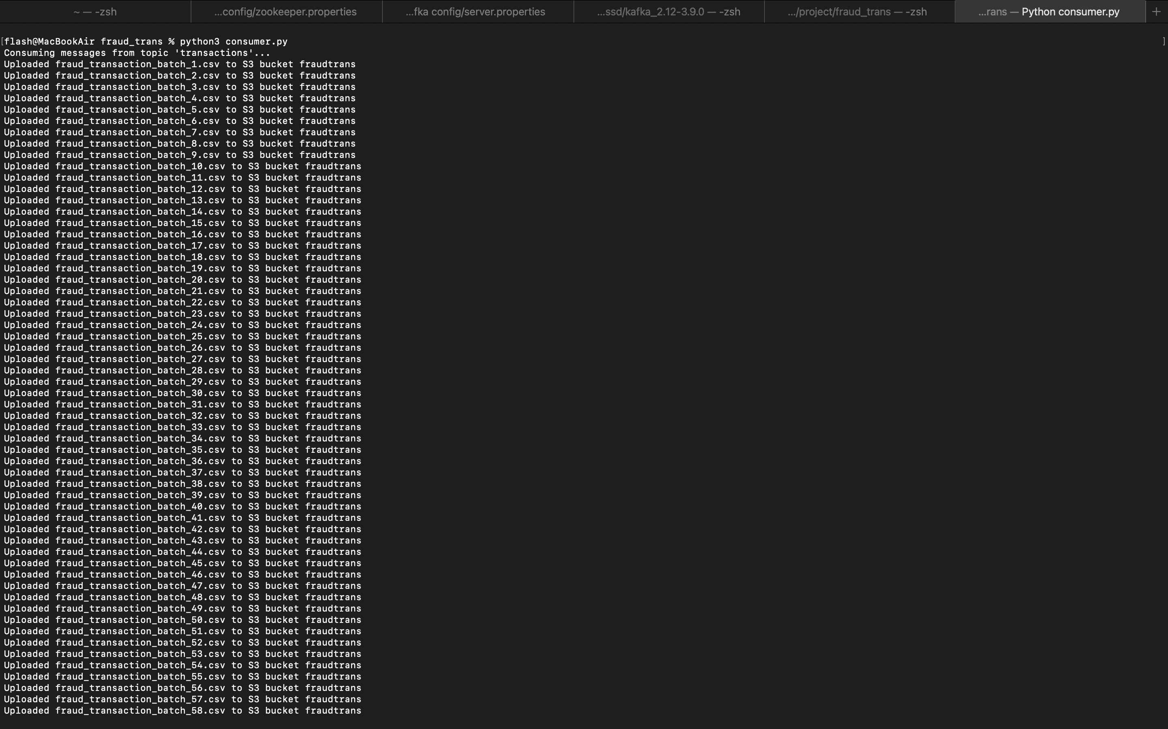

We can see the data has been sent to S3.

**Step 6:**

AWS S3:

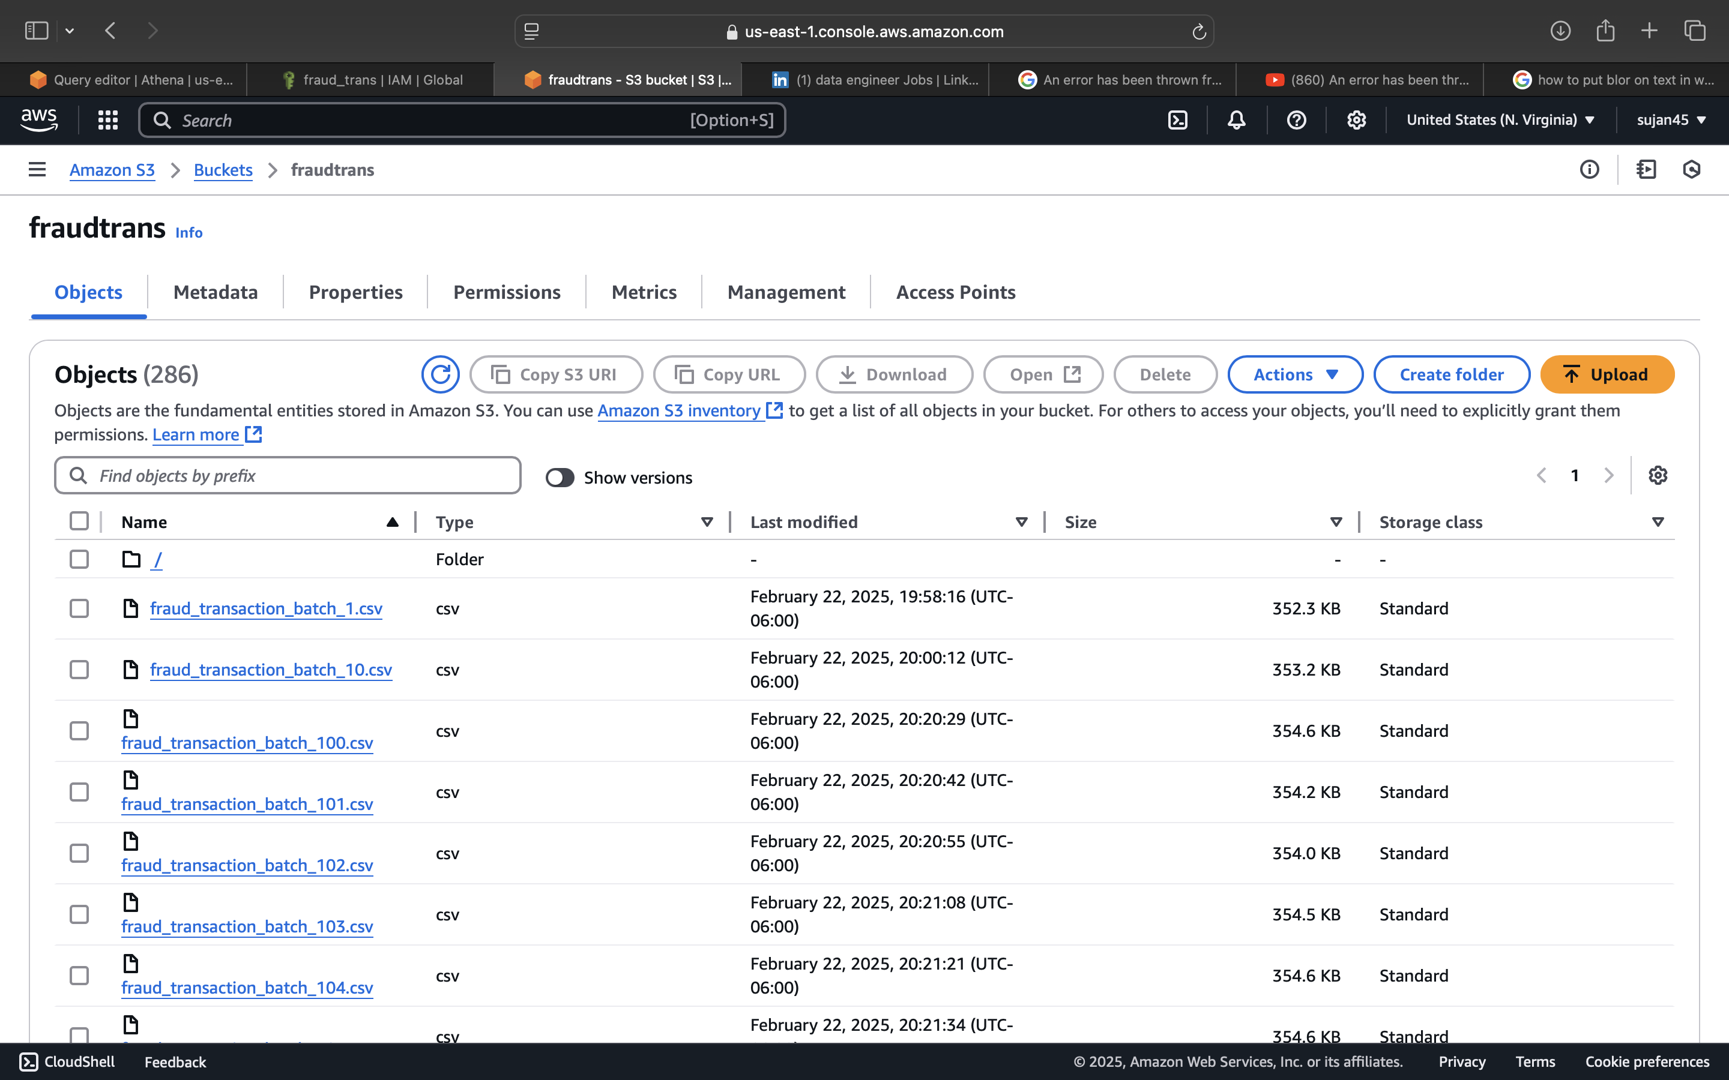

Data received from the consumer.

**Step 7:**

AWS Athena:

After creating database and table. A query has been done to showcase the results of the table.

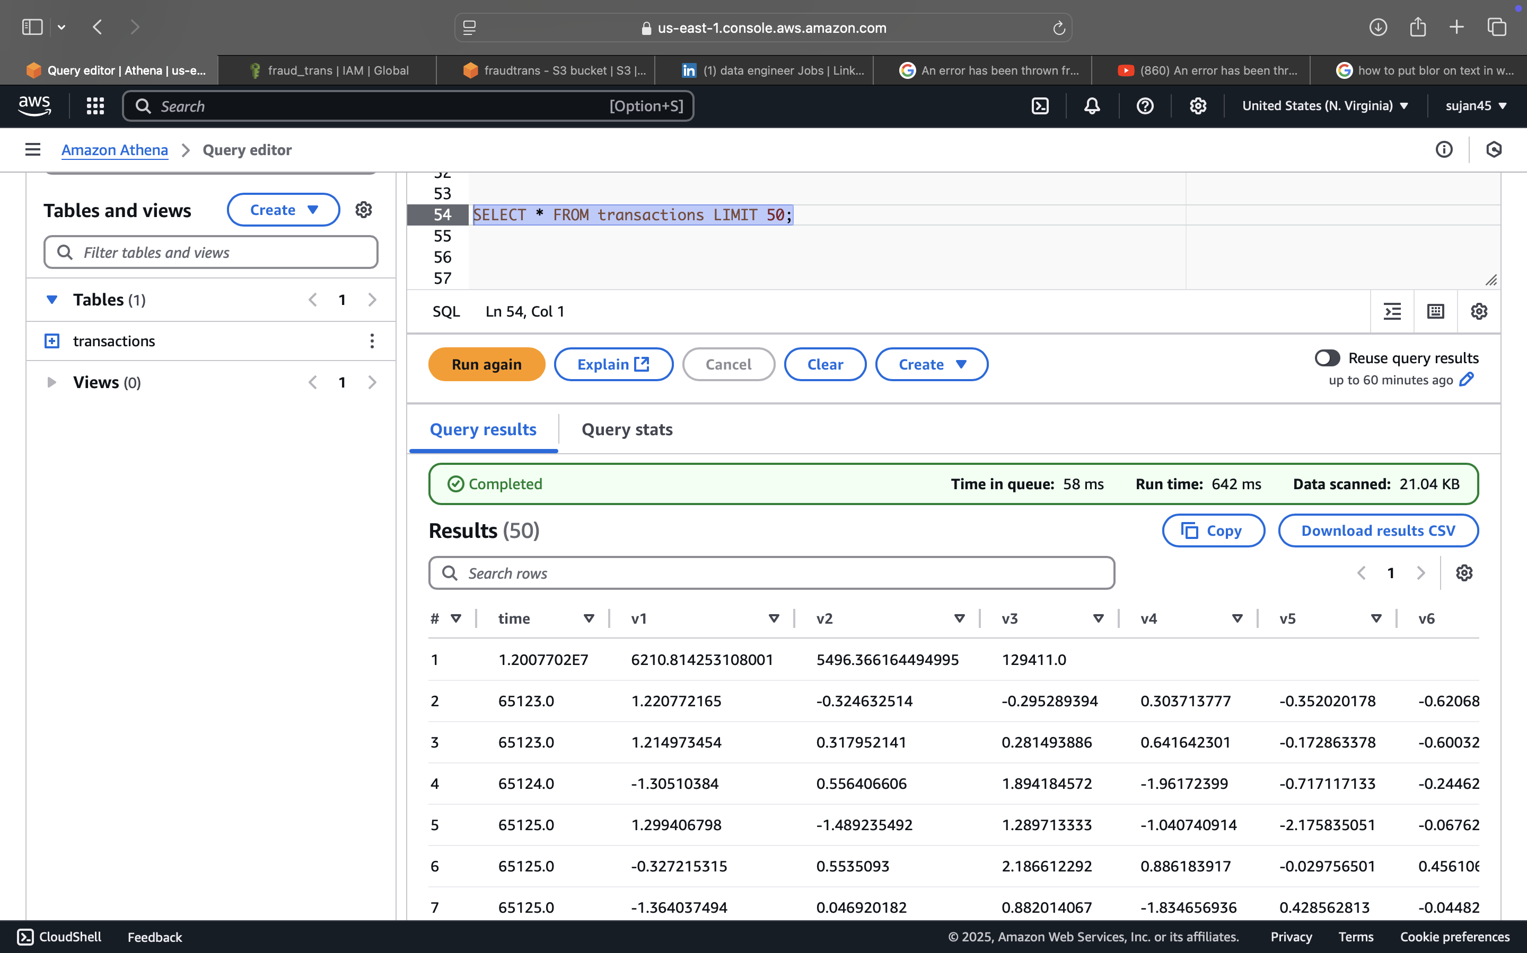

**Step 8:**

Data Visualization Using Tableau:

This depicts Fraud trend over Time:

